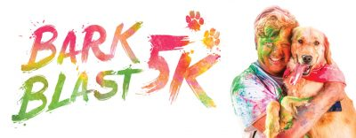
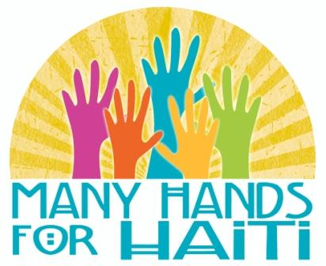

All proceeds from the MH4H Color Blast 5K benefit the ministry of Many Hands for Haiti.

GENERAL INFORMATION:
- Dogs must be on leash for entirety of the race
- Dogs must have rabies certificate or proof of vaccination
- Be prepared to pick up after your dog before, during and after the race
- Dogs must be well-behaved and able to be around large crowds, children and other dogs. Any dog or owner that is “out-of-line” will be asked to leave.
RACE DATE & TIME: Saturday, September 22, 2018 at 9:00 AM
Registration begins September 22nd at 7:30 AM

EVENT CONTACT: Tim Brand
tbrand@mh4h.org
www.mh4h.org/colorblast

ENTRY FEES: Dogs & owners must be registered for the race. Dog registration is $10.

AWARDS: As a fun run, the race will not be timed, and no prizes will be given to top finishers. However, there will be prizes awarded to the “Most Colorful” dog.

PROCEEDS: Proceeds from the MH4H Color Blast 5K will be used to fund food and feeding programs for families in Haiti. The cost of one adult registration for the Color Blast is equivalent to the cost of feeding one Haitian family for a whole month. One in three Haitian children is stunted or irreversibly short for their age due to malnutrition. Your registration helps provide much needed food for families in need.

PARKING: Parking will be available in the Trinity Reformed parking lot and downtown Pella.

PACKET PICK-UP: Packets can be picked up at the Many Hands For Haiti office (709 Main Street) on Friday, September 21st from 1-10 PM or Saturday, September 22nd at the registration booth at the Trinity Reformed parking lot from 7:30-8:45 AM. Packets will include a customized dog leash (guaranteed only if registered by September 9th), dog treats, and color pack.

ONLINE REGISTRATION: If you wish to register online, you can do so at www.mh4h.org/colorblast

- - - - - - - - - - - - - - - - - - - - - - - - - - - - - - - - - - - - - - - - - - - - - - - - - - - - - - - - - - - - - - - - - - - - - - - - - - - - - - - - - - -

DOG NAME (please print): _______________________________________________________________________________________

BREED: ______________________________________ OWNER NAME: ______________________________________

PARTICIPANT RESPONSIBLE FOR DOG: __________________________________________________

PHONE: ______ - ______ - __________ EMAIL: _________________________________________________________________

REGISTRATION COST: $ _____ ($10 per dog)
ADDITIONAL DONATION TO MH4H: $ _____
TOTAL: $ _____

EVENT DISCLAIMER: I am entering the MH4H Color Blast 5K, and I consider myself physically fit and adequately trained for the event. I understand the risks involved in this type of event on city streets in potential traffic, and I agree that I am taking part in this event at my own risk. By signing this application, I release Many Hands for Haiti and the event sponsors, organizers, and volunteers from any liability including claims for personal injury, death, and other damages that occur during the event. I give permission for the free use of my name and picture, and pictures of my pets, in any promotion, broadcast, or print media account of this event. By submitting this registration, I verify that I have a current rabies certificate or proof of vaccinations for my dog(s). My dog(s) will be leashed the entire time of the event.

SIGNATURE: _________________________________________________________ DATE: _______________________
(SIGNATURE REQUIRED FOR ALL RUNNERS. IF PARTICIPANT IS UNDER 18, PARENT MUST SIGN FOR THEIR CHILD.)
Make all checks payable to Many Hands for Haiti. Mail your entry to MH4H, PO Box 204, Pella, IA 50219.

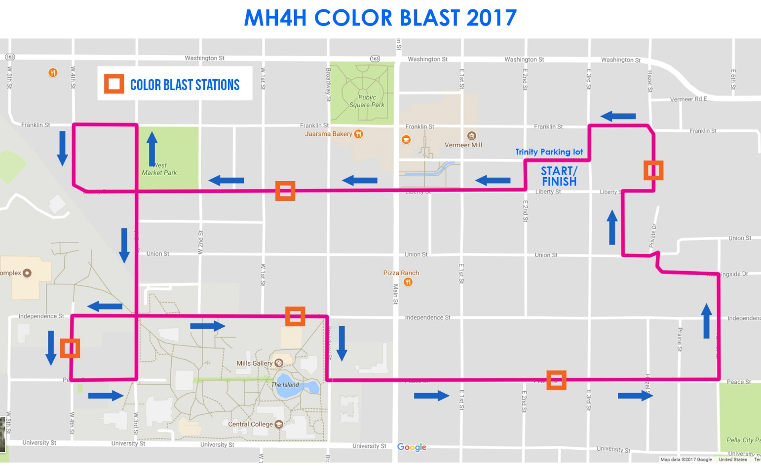

Come have a BLAST with us, as this un-timed race will take runners, walkers, bikers and furry friends through five different color stations where they will be covered in color powder from top to bottom! Plus, everyone who races will get free goodies after the race, use of a picture photo booth to capture the craziness, and music party in the street when they finish.

